***69th National Children Science Congress***

Focal Theme: - SCIENCE FOR SUSTAINABLE DEVELOPMENT

Sub Theme: - APPROPRIATE TECHNOLOGY FOR SUSTAINABLE LIVING

Title: - SMART DUSTBIN

Participants: -

1. Vaibhav Kr. Mishra
2. Harsh Narayan Jha
3. ABC
4. DEF

Index

|  |  |
| --- | --- |
| SR NO. | Title / Topic |
| 1. | Acknowledgements |
| 2. | Abstract |
| 3. | Introduction |
| 4. | Aims and Objectives |
| 5. | Methodology |
| 6. | Outcomes/Conclusion |
| 7. | Additional Project Ideas |
| 8. | References |

Acknowledgment

69th NATIONAL CHILDREN SCIENCE CONGRESS 2021

STATE- BIHAR STATE CODE- 10

Language: ENGLISH Category: Upper Area of Participation: Urban

Title: Smart Dustbin

Author’s Name: Vaibhav Kr. Mishra, Harsh Narayan Jha, ABC, DEF

Name of School: Kendriya Vidyalaya Air Force Station Darbhanga Bihar

Address of School: Kendriya Vidyalaya, Air Force Station, Darbhanga

District: Darbhanga State: Bihar PIN: 846005

E-mail: [abc@xyz.com](mailto:abc@xyz.com) Contact No. 9876543210

Abstract

Today in the modern and hygienic society, everyone is concerned about their hygiene. Throwing waste in Dustbin is an important thing to do in the favor of our environment, but the in-between task of touching the dustbin for opening it to throw the waste is somewhat people think unhygienic. If dustbins are not maintained then they can direct towards an unhealthy environment and can cause pollution that can affect our health. Foot open-able dustbins are a great achievement toward the above mentioned problems, but in this technological era, where everyone is evolving with the technology, our dustbins must evolve too. Modern problems require modern solutions. We are very pleased to introduce the society our idea of the “Smart Dustbins”.

The main objective of the project is to design a smart dustbin which will help in keeping our environment clean and also ecofriendly. We got inspiration from the Swaach Bharat Mission. Nowadays technologies are getting smarter day-by-day so, as to clean the environment we are designing a smart dustbin by using Arduino. This smart dustbin management system is built on the microcontroller based system having ultrasonic sensors on the dustbin. In this proposed technology we have designed a smart dustbin using ARDUINO UNO, along with ultrasonic sensor, servo motor, a battery, and some jumper wires for connections. After all hardware connections and software programming, our Smart Dustbin program will be ready to run. Dustbin lid will open when someone comes near the dustbin within the range of 5 cm then it will wait for user to put garbage and then automatically close. For society it will direct us towards health and hygiene, and from economical point of view it is affordable to as many as people, so that from poor to rich can take benefit from this.

Name and address of guide teacher:

PIN:

Phone:

Introduction

The basic working principle of our “Smart Dustbin” is using an ultrasonic sensor to emit ultrasonic sound waves to detect any person in front of our dustbin, which will in turn automatically open the lid of the dustbin to assist and promote the person to throw the waste in the dustbin. This automation of lid is achieved using a servo motor which helps in opening and closing the lid. The lid is also automatically closed after fixed time, as some people do not close the lid too.

Introduction to the parts of the dustbin:-

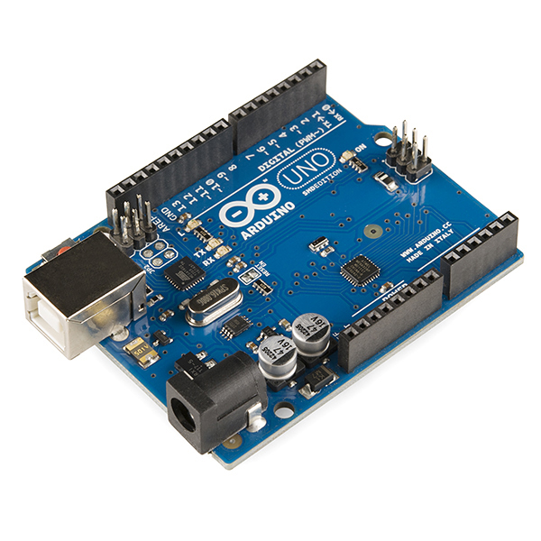

1. Arduino Uno: - It is a low powered microcontroller, embedded with microprocessor, USB port, digitals pins, analog pins, quartz clock etc. to make up an inexpensive microcontroller board, yet very fast than a human brain. We are using this microcontroller as the brain of our “Smart Dustbin”.
2. Ultrasonic Sensor (HC-SR04): - It is used to measure the distance to an object from the sensor by using SONAR, just like what bats do. It offers excellent non-contact range detection with high accuracy and stable readings in an easy-to-use package from 2 cm to 400 cm (1” to 13 feet). The operation is not affected by sunlight or black material, although acoustically, soft materials like cloth can be difficult to detect. It comes complete with ultrasonic transmitter and receiver module.

Figure : Arduino UNO

Figure : Ultrasonic Sensor

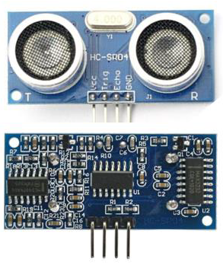

1. Servo motor: - It is a special motor which is capable of rotating at specified angles. Because servo motors use feedback to determine the position of the shaft, we can control that position very precisely. As a result, servo motors are used to control the position of objects, rotate objects, move legs, arms or hands of robots, move sensors etc. with high precision. We are using it to control the lid of the dustbin. Servo motors are small in size, and because they have built-in circuitry to control their movement, they can be connected directly to an Arduino.

Figure : Servo Motor

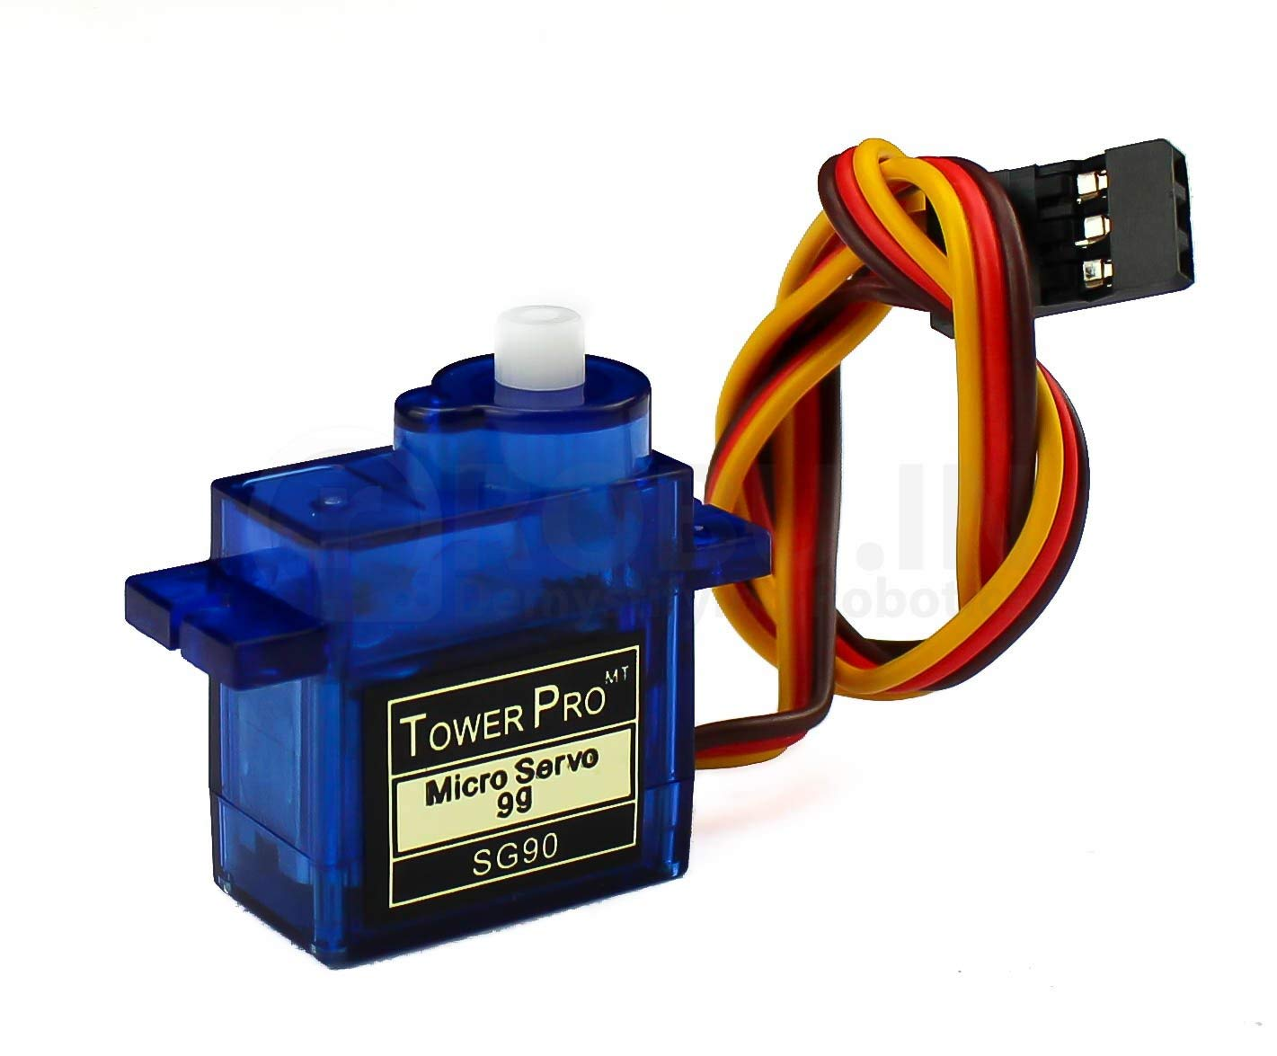

Aims and Objectives

The aims and objectives with our project are:-

* To make our society more hygienic.
* To promote the use of dustbins in small children using outstanding technology.
* To assist physically disabled people in using dustbins, especially in opening/closing the lid.
* Auto closing of dustbin lid, which usually many people do not do.

Methodology

1. Materials Required:

* Arduino Uno
* Servo Motor
* Ultrasonic sensor
* Jumper wires
* Breadboard
* Thread
* USB Cable (A to B)
* Power Supply
* USB Cable (A to A mini)

1. Experimentation:

The ultrasonic sensor sends out an ultrasonic wave, which in turn, if intersects with any person, is reflected back and the ultrasonic sensor receives the reflected wave, which we use to calculate the distance of the person from the dustbin. If this distance is less than a 20 centimeter, the servo motor is enabled to trigger the opening of the lid, reducing a hassle. And then after 5 seconds, the lid is automatically closed, thus reducing one more hassle.

The Arduino generates a 10-microsecond pulse on the TRIGGER pin, which causes the ultrasonic sensor to emit an ultrasonic wave. The waves are reflected back after hitting an obstacle, if any. Then sensor detects the reflected wave and measures the time interval. After that the ultrasonic sensor generates a pulse on the ECHO pin, whose duration is equal to the travel time of the ultrasonic wave. Then we use the below formula to calculate the distance of the person from the dustbin in centimeters.

We have speed of ultrasonic wave = SPEED OF SOUND = 340 m/s = 0.034 cm/s

The travel distance of the ultrasonic wave (in cm) = speed (in cm/s) * travel time / 2, and this is, mathematically,

0.017 * pulse duration

**Above is the Circuit Diagram of the Smart Dustbin:**

Figure : Circuit Diagram

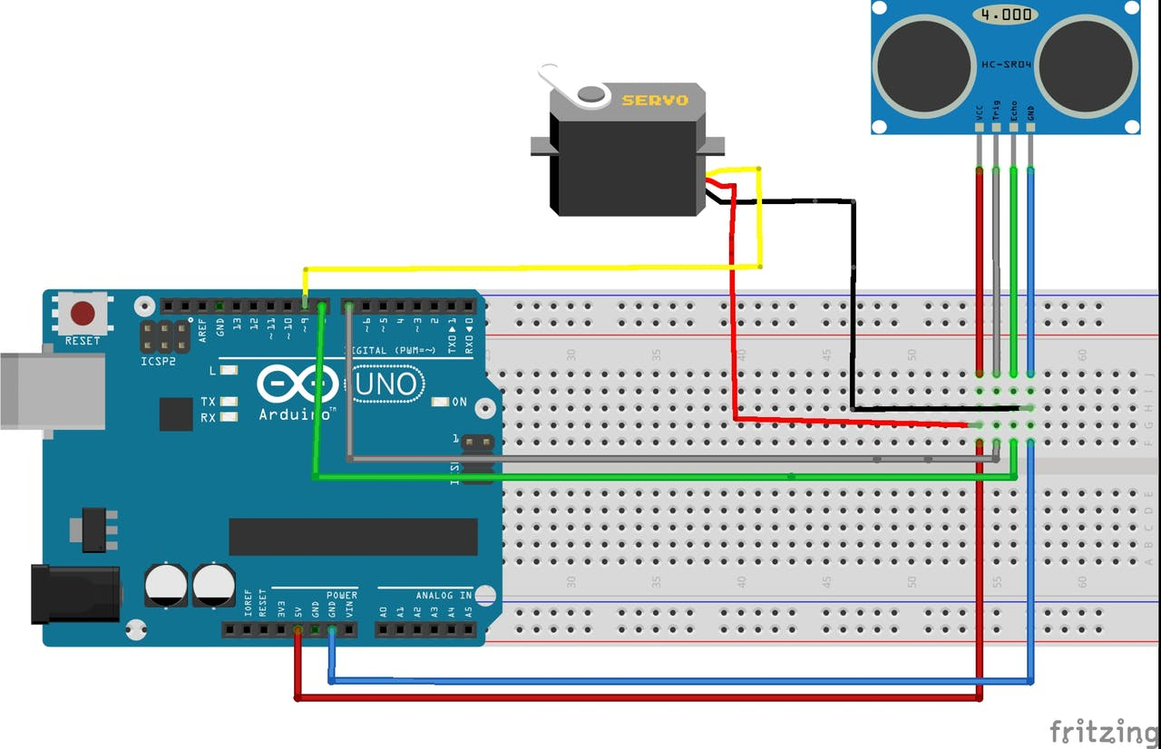

Outcomes / Conclusion

Being a very great project, this will surely help in the sustainable living of the society. This will result in a safer and cleaner environment. This will assist, promote and encourage people to use a dustbin and not throw the waste elsewhere, highly to the physically disabled ones. New technology fascinates small children. As a result, small children will be also inspired to use dustbins. The lid of the dustbin stays closed, so that waste is not exposed (to avoid flies and mosquitos), and it will automatically open whenever required.

Additional Project Ideas

While the current project is a great achievement, we do plan to do some more additions to it. At present, the dustbin is opening automatically, which is quite good. We are planning to add some wheels to the dustbin and use a proximity sensor, which together can converge into a dustbin that will come to the person at the press of a button. Say you are sitting on a chair doing some important work (with papers) and you tear and throw them a lot doing that. The dustbin is fixed in another corner of the room. You have to walk all the way to dispose the rubbish. Using our Smart Dustbin, one can just call it, it will come on its wheels, the lid will open, and then you can dispose the rubbish without wasting a bit of time. Other family members can use this also.

Second thing, it is currently able to detect persons in one direction only. We also plan to make it multidirectional and rotatable, so that everyone can use it from any direction.

References